April 11, 2017
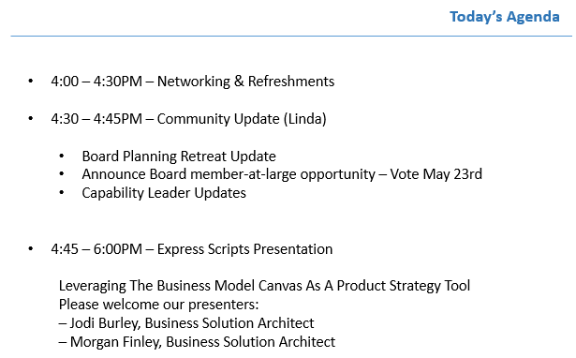

Thank you, everyone, we had a fabulous turnout with 60+ attendees…..room is full shortly after 4:00!
Approximately 90% of the attendees have been to TCBAF meetings in the past, with 10% first timers.

Community Update
Linda welcomed everyone and provided a community update:
- Review our Charter and History. These can be found on the website http://tcbaf.org
- The Board members held their annual retreat in February, where they reassigned duties and created the next 18 months of programming.
- The Board consists of 11 members
  - 7 are appointed by the corporate sponsors (Cargill, ExpressScripts, MetroState University, Target, Thrivent, Trissential, Medtronic)
  - 3 are elected positions
- Election will be held at the May meeting for 1 board position. If you are interested, come to the May meeting prepared to tell everyone why you are interested.
- Upcoming Community Events
  - May 23rd meeting hosted by Thrivent
“Customer-Centric Design – e.g., Journey Mapping, Values Streams”
  - June 20th Social Event at the Urban Growler
  - July 18th meeting hosted by Medtronic
“Business Architecture and IT Service Alignment”
  - September 19th meeting hosted by Target
“Strategic Planning 101” potentially a panel discussion
- Additional Events in 2017
  - IIBA PDD Collaboration – Sept 20th
  - October Social Event hosted by Trissential
  - MAC workshop / conference – Nov 8-9
  - December Summit hosted on the Cargill Campus

Opportunity Canvas
Morgan Finley & Jodi Burley (Express Scripts)

As Express Scripts is moving from Waterfall to Agile, they leveraged Deloitte to coach them through the process changes needed within the entire lifecycle. This Opportunity Canvas was one of the tools that has taken hold. It is evolving to be what Express Scripts needs it to be. It is basically in Pilot mode right now.

The purpose is to have a 1-page tool that facilitates discussion about a new feature or capability
It is simpler than the Business Model Canvas and the Lean Canvas, which are used to discuss new products.

There were a lot of tools in use before this pilot (for ex. Light weight business case, BCAT…). We have found the key is to build what makes sense for our situation. For example our goal, at this time, is to facilitate conversation, identify scope, and align on next steps. This tool has been successful satisfying that need for Express Scripts.

We already have our capabilities mapped to applications, and with the transition to Agile we see this tool allowing us to map products to capability. At that point we will have thorough mapping:
Product Capability Application

The BSAs use this opportunity canvas to facilitate conversation and replace the old intake form. Rather than interpreting the form data, we have the conversation. What is the problem statement, what is the current pain points…etc

The entire room had a chance to work with the opportunity canvas at the tables. Some of the feedback was:

- Find that there is a natural interaction from one area of the canvas to another. It wasn't a left to right nor top to down….but random across the page

- This feels like a project or value one pager rather than connected to business canvas. It was a great facilitation tool to gather information about the 'need'. Especially for someone that knows nothing about the business / topic.

- Format helpful to facilitate the discussion. Starting with value statement to align on the topic and then went to who, and then left to right from there.

- A lot of time on the problem statement…..likely a product of this impromptu exercise rather than the tool

At Express Scripts ---- we use this to generate ideas, prioritize, governance / approval process to feed into the product owners “product back log”.
Key audience of this tool is:
- Product Owners
- Solution Architects
- Technical participants --- who need to decompose the idea

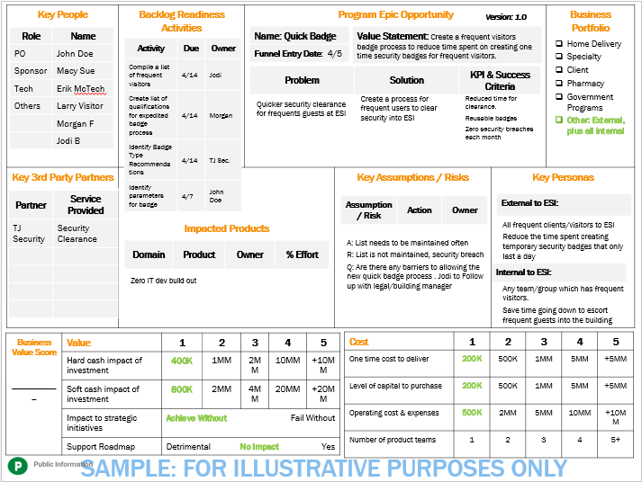

Background/supporting information:
The original tool was created by Jeff Patton, information is available on Patton’s website: http://jpattonassociates.com/opportunity-canvas/
The original template can be found:
  - PDF version
  - Editable PPT version

